**Lab-05 Excercises:**

1. Write a program to multiply AX by 27 using only Shift and Add instructions. You should not use the MUL instruction.

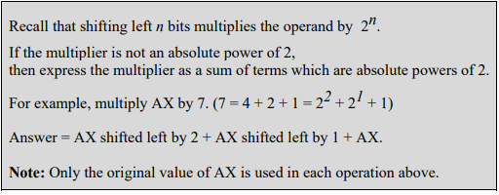

1. Write a program to divide AX by 8 using Shift instructions. You should not use the DIV instruction. Assume AX is a multiple of 8.



1. Write a program to check if a byte is a Palindrome. [Hint: Use Rotate instructions]. If the byte is a Palindrome, then move AAh into BL. Otherwise move 00h in BL.

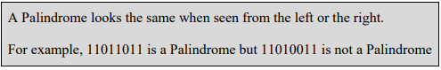

1. Write a program to display the bits of a register or memory location. Use the INT 21H interrupts to display data on the display monitor. [Hint: Use logical shift instruction to move data bit into the carry flag]

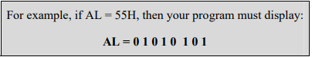

1. Write assembly code for each of the following high-level language assignment statements. Suppose that A, B, and C are word variables and all products will fit in 16 bits. Use IMUL for multiplication. It's not necessary to preserve the contents of variables A, B, and C.
2. A = 5 x A – 7
3. B = (A-B) x (B-10)